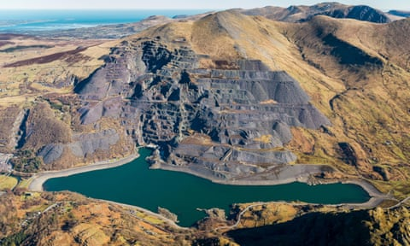

Elidir Fawr in north Wales, inside of which sits Dinorwig power station, AKA Electric Mountain. Photograph: Tony Trasmundi/Alamy

[**The long read**](https://www.theguardian.com/news/series/the-long-read)

**Electric mountain: the power station that shows the beauty of infrastructure**

Utilitarian as they may be, some civic projects are so monumental they approach the sublime. And one of the most elegant is hidden inside a mountain in Wales

by [Deb Chachra](https://www.theguardian.com/profile/deb-chachra)

Thu 2 Nov 2023 06.00 CET

**I**’ve been fascinated by science and engineering my entire life. The first thing I remember wanting to be when I was a kid was an astronaut – it was the 1970s, the cultural peak of space exploration. By the time I was 10, I wanted to be a nuclear physicist, and this took me all the way through to a degree in engineering physics.

I was born in Canada, but when I was nine, my family lived in Bhopal, India, in my father’s family home, for six months. If culture is everything that you do without thinking about why you’re doing it, then our infrastructural systems, and the ways of life they make possible, are unquestionably an important part of culture. Even as a child, the differences between Canada and India – language, social norms, the deep poverty and the unignorable inequality – required serious adjustment.

In Bhopal, we only had running water for an hour or so in the morning and again in the evening. We collected it in buckets to use for bathing and flushing toilets the rest of the time. My mother boiled and filtered the water to make it potable to digestive and immune systems that were accustomed to clean, cold, carefully treated water from Lake Ontario. We quickly learned to expect dimming lights and power cuts as the growing city’s electrical grid struggled to cope with the fans and evaporative coolers that were brought to bear against the summer heat.

I doubt I would have given much thought to infrastructure had I not lived in these two different places. By moving to Canada, my parents had given me a new citizenship in a country with a different set of educational and economic opportunities, alongside the infrastructure that made it possible for me to access them.

Collective infrastructures – water and sewage, transportation, electricity, telecommunications – are good candidates for the most complex systems created by humans. They are planetary in scale, build on their own histories, interact with one another and have effects that extend far into the future. Their design, construction and operation require a wide range of technical disciplines – civil engineering, obviously, but also electrical engineering, mechanical engineering, environmental engineering, and the science of systems and of networks. All of these fields incorporate not just technologies but practices, ways of thinking, doing and building.

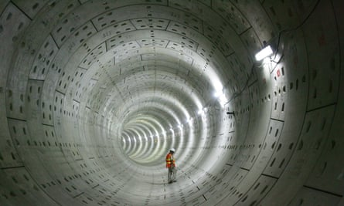

A Delhi Metro tunnel under construction in 2009. Photograph: Anindito Mukherjee/EPA

Conservationists sometimes refer to animals like pandas, elephants and polar bears as “charismatic megafauna”. Large, easily recognisable and beloved, they make excellent representatives for wildlife and for their homes. All over the world, charismatic megastructures are the public, and often similarly beloved, faces of our collective infrastructural systems. Bridges, of course, but also the soaring spaces of railway stations, from Grand Central terminal in New York City to the Chhatrapati Shivaji Maharaj terminus in Mumbai. In my home town of Toronto, the CN Tower, built to be a communications hub, makes the skyline instantly recognisable. The Hoover Dam, in the desert outside Las Vegas, hosts 7 million visitors every year.

I have a deep affection for a lot of charismatic infrastructural megastructures. When I transit through Chicago O’Hare or London’s Heathrow, it feels as if I’m in the beating heart of the world, at the nexus of worldwide systems and thousands of human stories. I still feel warmly toward Toronto’s Pickering nuclear generating station, where I spent a lot of time as a child. It was easily visible from the beach at the end of our road, and to a tech-obsessed child, the power plant was my local, personal charismatic megastructure. I also adore the calm quiet of the paired hydroelectric power plants set inside green and forested Niagara Gorge, several miles downstream of the thunderous falling water and throngs of tourists at Niagara Falls. But if I had to name a favourite, one infrastructural installation does stand out. It’s simultaneously enormous and almost entirely hidden, an elegant engineering project that serves what at first seems to be an almost whimsical human purpose.

Eryri, or Snowdonia national park, in north Wales, is idyllic, all green hills surrounding blue glacial lakes. Old farmhouses, ruined castles and modern buildings alike show off the gorgeous locally quarried slate, which grew into an important industry in the 19th century ([the region recently became a Unesco world heritage site](https://www.visitwales.com/destinations/north-wales/eryri-snowdonia-mountains-and-coast/six-areas-unesco-awarded-slate) because of the historic mining facilities). A Victorian-era railway carries tourists to the top of Yr Wyddfa (Snowdon), to take in the view. If you’re lucky enough to be there in May, like I was, the charm of the landscape is further enhanced by absolutely adorable gambolling baby lambs everywhere. But I was there to see something that had been made deliberately, carefully and beautifully invisible, concealed inside a giant cavern carved out of a mountain. Like a supervillain in their lair, it gathers power to itself, usually under cover of darkness. It’s just that the power, in this case, mostly lets people watch TV and make tea.

Eryri is the home of Dinorwig power station, popularly known as Electric Mountain. Until fairly recently Dinorwig offered guided tours, and so one day I made my way there with some friends who live in northern England to join one. It began with an introductory video describing the facility, filled with claims about its size: “The largest cavern in Europe!” “Two Empire State Buildings high!” We boarded a minibus that trundled through the Welsh countryside, passed through several security gates, and then went down a tunnel deep into the mountain itself, Elidir Fawr (Big Elidir), named after a sixth-century warrior king.

**C**onventional electrical grids largely operate with just-in-time energy production, where the exact demand is estimated on a minute-by-minute basis, and electricity is generated and allocated accordingly. The system is continuously monitored, because failing to match demand with adequate supply leads to power restrictions or even blackouts. Most of the demand is predictable. There’s a daily cycle of electricity usage, commonly known as the “[duck curve](https://www.energy.gov/eere/articles/confronting-duck-curve-how-address-over-generation-solar-energy)”, tracing the profile of a duck’s back and neck over the course of the day. The duck’s tail is the low morning peak, as people wake up and start their day, the steady demand through to the late afternoon follows the line of its back, and then a sharp rise in demand corresponds to the back of the duck’s neck, peaking at the top of its head in the evening, as everyone turns on lights, makes dinner, does housework or has the TV on. Finally, there’s an overnight low in aggregate demand while most people are sleeping.

For unusually high loads, electricity is often supplied from “peaker plants”, designed to be brought online as needed, and which run on fossil fuels, usually fossil gas. While expensive to operate, the electricity they produce commands a premium price because of the high demand. Electric Mountain is a kind of peaker plant, but part of what makes it special is that it can go from idle to producing power in minutes, or as little as 15 seconds from standby mode.

Construction at Dinorwig started in 1974 and the facility came online 10 years later. In the control room, operators ensure an adequate supply of electricity in the grid by carefully monitoring their inputs, ready to act when needed. One of those inputs is watching television. Electric Mountain was conceived and designed in the late 1960s, and the period between then and the 1990s was the heyday of synchronous broadcast television, where nearly everyone in the UK might be watching the same TV series or sporting event at the same time. And then, when the show was over, a substantial fraction of the viewing populace did the same thing, in a phenomenon known as “TV pickup”: they reliably and immediately switched on a power-hungry electric kettle to make tea. Alert operators could open a set of valves the instant the television broadcast ended, sending a spike of power into the grid in less time than it took for viewers to get up from the sofa, stretch and walk into the kitchen.

This rapid response is possible because Electric Mountain is a pumped-storage hydroelectric station. From the outside, the installation consists of Elidir Fawr and two placid, slate-bottomed lakes: Marchlyn Mawr, high on the flank of the mountain, and Llyn Peris, nestled in the valley between Elidir Fawr and Yr Wyddfa. The 500 metres or so of altitude difference between the two lakes allows them to serve as upper and lower reservoirs, connected by a vertical shaft inside the mountain.

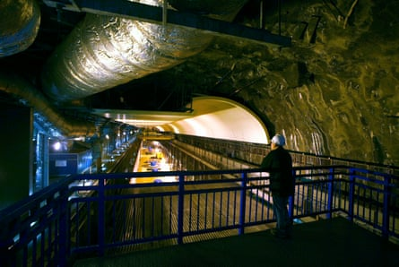

The machine hall at Dinorwig power station, AKA Electric Mountain, in north Wales. Photograph: Bloomberg/Getty Images

When an operator opens the valves at the top, water from Marchlyn Mawr flows in, falls straight down on to the turbines of six generators lined up in the cavern in the mountain – big enough to comfortably house St Paul’s Cathedral, it’s familiarly known as “the concert hall” – and then out to Llyn Peris. At full flow, enough water to fill a 25-metre swimming pool passes through the turbines every second (appropriately enough, the tour guide described this as “1.5m cups of tea”), but even at this rate, the artificial waterfall inside the mountain can generate electricity continuously for six hours before Marchlyn Mawr is depleted.

All of this is impressive enough, and by being able to produce this power at a moment’s notice, Dinorwig dramatically increases the reliability of the UK electrical grid. But the real elegance, to my mind, is what happens next.

When demand is low, there’s surplus capacity available because of baseload power generators that supply a near-constant amount of electricity, such as nuclear power plants. So, after all those television-watching Britons go to bed, Dinorwig’s generators are run *backwards*. Instead of the falling water spinning the turbines to generate electricity, power is fed into the generators, causing the blades to rotate.

Now it’s an electrical motor, and the turbine works as a pump, lifting water from the valley all the way back up the shaft to the higher reservoir, and so resetting the system. It’s a remarkably efficient process, with about 75% of the energy available for reuse. Electric Mountain makes engineering sense as a way to deal with unpredictable spikes in demand, but it also makes economic sense because it can time-shift energy usage from expensive high-demand times to cheaper low-demand periods, arbitraging the price difference. What’s more, power from pumped-storage hydro has a much lower carbon footprint than conventional peaker plants.

Dinorwig sets my engineering heart aflutter not just for its scale, but because of its undeniable elegance, the way it solves a problem by using the available resources – mountain lakes! Low overnight demand! – cleverly and parsimoniously. And Dinorwig is becoming more useful and valuable, not less. As renewable electricity generation increases, the inherent variability of sources like solar and wind means that more grid-scale energy storage is necessary in order to make sure that there’s always electricity available to meet demand. A pumped-storage hydroelectric power station like Dinorwig is effectively a giant rechargeable battery.

**I**mpressive though Electric Mountain is as an engineering accomplishment, that’s not what I think is the most astonishing thing about it. It cost nearly £500m to excavate the inside of Elidir Fawr and construct the facility, making it, at the time, the largest civil engineering contract ever awarded by the UK government. But in a larger sense, what really makes Dinorwig and similar megafacilities remarkable is the level of social, political and economic organisation that underpins the decision to build them at all.

The economic argument for building systems like Dinorwig is that the large initial investment pays off: once the system is built, it makes provision cheaper for a long time afterward. Public infrastructure is often funded with bonds, because the large upfront cost can be balanced against their steady payout rate over time. This seems mundane, but it’s actually remarkable.

First, the construction of systems like these is predicated on the belief that there will be a stable community in place to benefit from them, typically for decades to come. They’re an investment into a vision of a shared future. Next, the economic argument for their value is strengthened by universal provision because the capital and operating costs can be spread out over more users. Finally, membership in that social collective is primarily based on where you are, not on kinship, social class or anything else.

One of the most profound and sustained ways in which we are in a relationship with other people is just by living near them and sharing the physical systems we use to meet our needs. A focus on the engineering and technical considerations of infrastructural systems can tell you that the most efficient thing to do is to build a centralised water treatment plant and a network to distribute it. But this can only be achieved – planned, designed, and paid for – collectively. A pumped-storage hydroelectric plant or a municipal water system is a physical manifestation of an ongoing relationship between the people who share it.

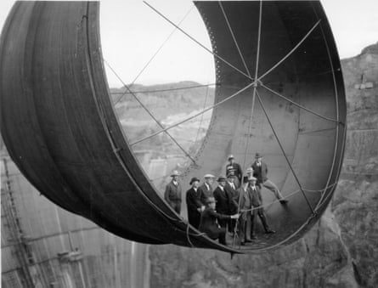

The construction of the Hoover Dam in the 1930s.

Because infrastructural systems contribute to economic growth, cooperating to build a municipal water supply or a public power utility is a way for a community to leverage its economic surplus and stability by reinvesting it to create even more cooperation and surplus in the decades to come. This sustained, mutually beneficial relationship between people who are near one another, mediated in part through infrastructural systems, can itself become a factor in the uneven geographical distribution of wealth.

But Dinorwig tugs at my heart, not just my head, because of how it incorporates other values besides efficiency and economics. It was built as the local slate quarrying industry was in decline, and the workers on the project included retrained former miners. When Marchlyn Mawr and Llyn Peris were turned into reservoirs, the arctic char living in the lakes were relocated. (This seemed like a lot of effort to go to for some fish – arctic char are widespread and commercially fished across northern Canada – until I learned that they are locally endangered in the UK, since only a few small populations had managed to hang on since the end of the last ice age in a handful of Welsh lakes.) And it’s no accident that Electric Mountain is all but hidden; the entire power station and its facilities were designed to blend into the scenic landscape. There are no marching rows of electricity pylons, since the transmission lines are buried underground. None of these were purely financial decisions; there was no return on investment measured in pounds sterling.

**I**nfrastructural systems are more than just technical – they are social and political. They are shaped by the sustained relationships of the people who live in the places they connect, and they also form part of that relationship. They can’t easily be valued or assessed like a consumer good, where it’s “worth it” to buy something or not. Deciding to buy a car has little in common with deciding when, where and how to build the roads to drive it on. So infrastructural systems don’t lend themselves to decision-making that focuses solely on the costs or the returns on investment.

An infrastructural network can encode and promote a set of values: *everyone should have access to clean water*, or *electricity is a necessity*, or *personal mobility is a human right*, or *a healthy population is important*, or *broadband access is required to fully participate in civic society*, or even *endangered fish should be protected*. While infrastructural systems can meet basic human needs, providing agency and freedom, the specific form they take depends on cultural norms and expectations; in turn, the systems set and define those norms and expectations.

Pumped-storage hydroelectric stations are used globally, but I love Dinorwig in particular because it really foregrounds how infrastructural systems are built to fulfil human desires, and how specific, contingent, and culturally situated these desires can be. It’s so much more than a cup of tea at the end of a TV programme. What do people want? How can these desires be fulfilled? How are the desires of different communities balanced? How are the necessary resources distributed? These are political questions, not engineering questions. But in infrastructure, the political and the engineering questions are linked. And the end result might be a power station that makes itself invisible, all the better to preserve the beauty of the landscape around it for generations to come.

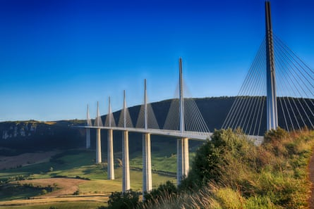

The Millau viaduct in France. Photograph: Bensib/Getty

The most important and radical promise of infrastructural systems is not just that they underpin our individual agency, but that they can do so in a way that is democratic and universal. Most technologies are sold on the premise of contributing to our freedoms and giving us more time, but infrastructural systems have genuinely demonstrated that they can do this, and in an equitable way. Over and over again, as new technological systems have been invented and the networks have begun to be built out, their efficiency, their value, and the way they enable personal, civic and economic agency have been recognised, along with technical, social and economic incentives to move toward universal provision – to treat the services they provide as a public good, in all senses of the phrase.

As infrastructural networks become more widespread and reliable, we begin to build other systems on top of them; this provides a powerful incentive to make them even more widespread, reliable and enduring. Around the world they have been the roots and the fruits of sustained economic and political cooperation: enabling groups to use and steward resources that are held in common for collective benefit, and to make decisions that are in the best interests of the community. Shared systems are used to meet basic needs, to provide services, to foster social connections and to provide access to physical goods. Infrastructural systems are how we take care of each other and plan for a future of long-term investment and cooperation.

**A**t the very end of our tour of Electric Mountain, our minibus reemerged into the cool grey of a summer day in [Wales](https://www.theguardian.com/uk/wales) to skirt the lower reservoir and return to the village at the foot of Yr Wyddfa where we began. En route, we passed an unassuming building that blended perfectly into the surrounding landscape of green hills. It was perhaps two storeys high, with a steeply pitched roof, faced in the same local slate as the picturesque ruins of Dolbadarn Castle across the lake.

Inside the building is an emergency power system: diesel generators with their fuel supplies, connected to a bank of storage batteries. In the event of a complete systems failure – a blackout across the entire island of Great Britain – this facility can provide enough electricity to open the valves at Dinorwig, releasing water from the upper reservoir to fall on to the spinning turbines, powering up the station and sending the electricity out to the [National Grid](https://www.theguardian.com/business/nationalgrid) to bring other systems back online in turn. It’s called a “black start”.

[[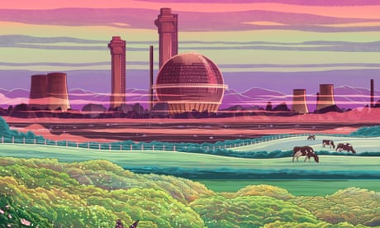](https://www.theguardian.com/environment/2022/dec/15/dismantling-sellafield-epic-task-shutting-down-decomissioned-nuclear-site)](https://www.theguardian.com/environment/2022/dec/15/dismantling-sellafield-epic-task-shutting-down-decomissioned-nuclear-site)

[Dismantling Sellafield: the epic task of shutting down a nuclear site](https://www.theguardian.com/environment/2022/dec/15/dismantling-sellafield-epic-task-shutting-down-decomissioned-nuclear-site)

[Read more](https://www.theguardian.com/environment/2022/dec/15/dismantling-sellafield-epic-task-shutting-down-decomissioned-nuclear-site)

For humanity, fossil fuels like coal and crude oil were our black start, literally and figuratively. They were conveniently stockpiled underground, easy to access, easy to move around and easy to use; after all, people have been creating energy by combustion since [before we were even *Homo sapiens*](https://www.theguardian.com/science/2023/sep/19/justice-for-neanderthals-what-the-debate-about-our-long-dead-cousins-reveals-about-us). Fossil fuels lifted us out of darkness, giving us the time and resources to create our global, connected, highly cooperative, technological civilisation. But above all, fossil fuels created the conditions for humanity to invent the renewable energy technologies that will supplant them.

Like the diesel generators at Dinorwig, fossil fuels are a transition phase, not something we want to or even can rely on indefinitely. Our civilisation is up and running, and now it’s time to throw the switch that takes us from the pollution and inefficiency of our black start and powers up a future of sustainable energy and everything that it makes possible.

 This article was amended on 2 November 2023 to clarify that the Dinorwig visitor centre is now closed indefinitely and guided tours are no longer offered.

*This is an edited extract from How Infrastructure Works: Transforming Our Shared Systems for a Changing World by Deb Chachra, published by Torva and*[*available at guardianbookshop.com*](https://guardianbookshop.com/how-infrastructure-works-9781911709541)

 Follow the Long Read on Twitter at [@gdnlongread](https://twitter.com/@gdnlongread), listen to our podcasts [here](https://www.theguardian.com/news/series/the-long-read) and sign up to the long read weekly email [here](https://www.theguardian.com/info/ng-interactive/2017/may/05/sign-up-for-the-long-read-email).